Task 1 — Prove the toolchain
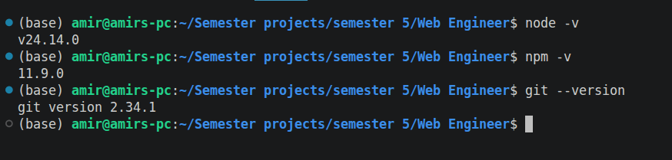

Task 2 — Network detective
Website: Google
1. Number of requests:
77 requests
2. Largest file:
1.10 MB
Type: JavaScript (JS)
3. Non-200 request:
Status: 302 — Found (Redirection)
What happened:
The server redirected the browser to another URL/resource. The browser followed the redirect automatically.
Screenshot:
